**SET 2**

Question 1: Implement SRTF. Compute waiting time, turnaround time

OUTPUT:

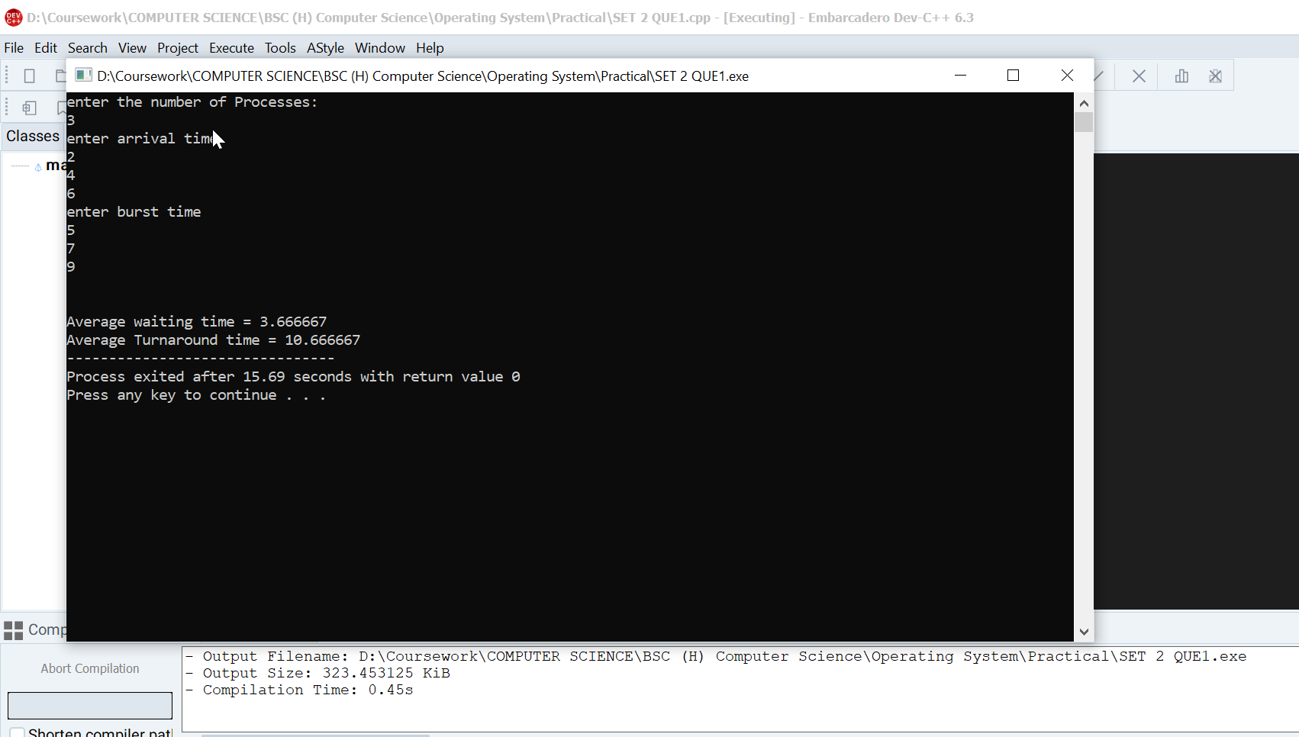

Question 2: Write a program to demonstrate fork where parent and child run same codes and child process should run first

OUTPUT:

